**Investigation of Plasma Compression for Exotic High Energy Physics Environments**

AFOSR BAA: FA9550-19-S-0003

*Patrick Michael Brown*

*United States Air Force Institute of Technology*

*Wright Patterson Air Force Base, OH*

[Patrick.Brown@afit.edu](mailto:Patrick.Brown@afit.edu)

**Executive Summary**

The research area of high energy plasma compression and acceleration is on the forefront of fusion/plasma physics, astrophysics, nuclear physics, and general relativity. For the past year I have been involved in this research for my Master’s Thesis, specifically the Plasma Jet Driven Magnetoinertial Fusion (PJMIF) being investigated by the Plasma Liner Experiment (PLX) at the Los Alamos National Laboratory (LANL), as illustrated in Figure 1.

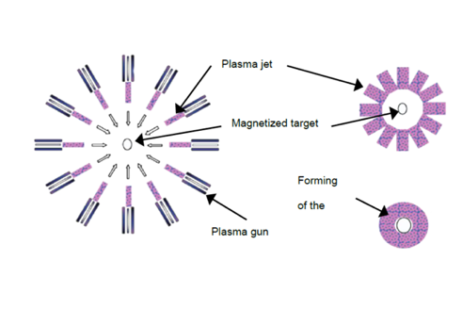

Figure 1. The Plasma Liner Experiment First Phases: plasma acceleration by drivers, plasma acceleration in vacuum towards target, and liner formation. [1]

For PJMIF and the PLX, there are two main areas of interest that require substantial theoretical and computational work. The first, is the acceleration of beams of heavy ion plasmas (heavy ion drivers). Investigating heavy ion drivers not only allows us to research new techniques of plasma acceleration to high velocities and plasma beam focusing, but also allows us to research new physics and engineering in the area of spacecraft plasma propulsion and fusion propulsion; both of which represent areas of great interest to the United States Air Force and the Space Force. The second main area of interest is the compression of magnetized plasma targets to fusion/high energy conditions. This represents the most intriguing aspect of the research. High energy plasma compression not only allows us to look at simulations of weapon detonations and possible break-even fusion reactions; it allows us to simulate the most exotic realms of our universe; such as core collapse supernovae and the creation of exotic spacetimes.

**Statement of Work**

Research Focus:

The focus of the proposed research is to investigate the physics of high energy plasma compressions. As stated above, plasma compression of plasma targets to high energy conditions can be used to test fusion reaction scenarios and to simulate high energy astrophysical environments such as core collapse supernovae and exotic spacetimes like those necessary for the creation of wormholes and warp drives; as well as nuclear weapons environments. The problem facing physicists today is a detailed understanding of the physics of these compression scenarios from the quantum field theory (QFT) and particle perspectives is lacking. This is due mainly to the complexity of modelling QFT and particle physics, especially when taking into account the high energy environments of plasma compression.

My research proposes to investigate the complexities of high energy plasma compression through the lenses of QFT and particle theory using recent advances in kinetic plasma theory, such as those in gyro-kinetic plasma theory [5] and Discontinuous Galerkin methods for computational plasma physics [4]. The purpose of this research would be to use the theory and computational models gained, and then applying them to investigate the creation of exotic spacetimes necessary for the creation of wormholes and warp drives [3,6], core collapse supernovae [7], and fusion conditions [1,2].

Research Objectives:

1. *Research the heavy ion plasma accelerators necessary to compress the magnetized plasma targets to the necessary conditions*.

As mentioned earlier, my master’s thesis will create models of a new class of heavy ion drivers for PJMIF; specifically heavy ion drivers utilizing longitudinal beam compression and transverse focusing. The problem with current heavy ion drivers is that either they do not accelerate the plasma to the necessary velocities or they are subject to blow by where the plasma disperses due to some regions of the plasma accelerating past the others.

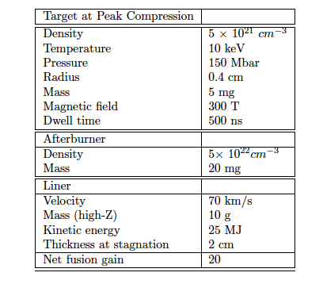

Table 1. Baseline configuration parameters for ideal PJMIF design. [1]

My models and theory have been based on the magnetohydrodynamic (MHD) description of plasmas. These types of models are very useful for creating necessary engineering designs and investigating large scale plasma motion and excitation.

For the proposed research I would extend the models to kinetic theory. This would create detailed models of the driving characteristics that could detract from the acceleration and compression/focusing of the beam as shown in Figure 2 [2]. This would also allow the models created for the drivers to be expanded to plasma and fusion propulsion. The schemes used to accelerate the heavy ion plasma in the drivers are similar to the schemes used to accelerate plasma for spacecraft propulsion either through plasma expulsion or fusion propulsion schemes, such as magnetic nozzles and beam compression. Investigating the heavy ion drivers would therefore also shed light to the instabilities created in plasma and fusion propulsion schemes [1].

2. *Create the theoretical and computational models of plasma compression from the perspective of QFT and particle theory*.

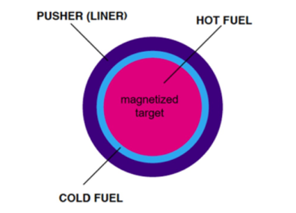

Figure 2. Magnetized plasma target compression concept for PJMIF. The heavy ion drivers form the pusher (liner) on the outer edge, the drivers also carry with them a layer of cold fuel at the their tips, and the hot fuel (magnetized target) is at the center. [1]

This is the more intriguing aspect of this research project, as it has the more exotic applicability. As stated before, the models of the compression of magnetized plasma targets have been lacking the QFT and particle theory due to the theoretical and computational complexity of the task. Recently, there have been great advances in plasma theory with regard to gyro-kinetics and computational plasma physics, such as new Discontinuous Galerkin Methods, as well as the increasing application of quantum computing to computational physics. Due to these developments, complex simulations of high energy plasma physics are now becoming more accessible.

For the proposed research, I would use these advancements to create more detailed models of high energy plasma compression that would allow for the inclusion of detailed QFT and particle theory. This research would then be used to model exotic high energy astrophysical and plasma environments. It will focus on the necessary conditions to create and maintain traversable wormholes and warp drives [3,6], core collapse supernovae leading to black hole formation [7], fusion energy conditions [1,2], and also nuclear weapon detonations [2].

3. *Experiment*

The Plasma Liner Experiment at the Los Alamos National Laboratory is currently being used as the main test bed for the PJMIF concept, for both the heavy ion drivers and magnetized plasma target compression [1]. Therefore, this is the obvious choice to use as a test bed for this research, as well as my master’s thesis. This would be used to test both the heavy ion drivers and plasma compression for this research.

**Research Plan**

* Model heavy ion drivers using gyro-kinetic and kinetic theory and computationally model using Discontinuous Galerkin methods using my master’s thesis as the basis.

*Time: 6 months*

* Model plasma compression with inclusion of QFT and particle theory using gyro-kinetic and kinetic theory and computationally model using Discontinuous Galerkin methods using my master’s thesis as the basis. *Time: 18 months*
* Extend models of compression to the creation of wormholes and warp drives, core collapse supernovae and black hole formation, break even fusion reactions, and nuclear weapon detonations. *Time: 12 months*
* Note: Throughout time frame, experimental design and collaboration will be ongoing with the PLX at LANL

**Deliverables**

The deliverables for this project are many and varied, it is my intention that they will include:

* Publications focusing on in-depth theoretical and computational understanding of plasma compression and acceleration.
* Publications focusing on in-depth theoretical and computational understanding of exotic and high energy astrophysical environments.
* Computational code written to simulate the physics of this research.
* Presentations at conferences regarding this research.
* Technical reports and experimental designs for the engineering of the experiments to test the theory and computation.

**References**

1. Y. C. F. Thio, et al. “Plasma Jet Driven Magneto-Inertial Fusion,” *Fusion Science and Technology,* 2019.

2. Cassibry, Jason. “F/DOE/Formation of Imploding Plasma Liners for Fundamental HEDP Studies and MIF Standoff Driver Concept Exploration.” **DE-SC0003560**

3. Visser, Matthew, “Lorentzian Wormholes: From Einstein to Hawking,” *Springer*, 1996.

4. Juno, J. et al. “Discontinuous Galerkin for fully kinetic plasmas,” *Journal of Computational Physics*, 2018.

5. Shi, Eric Leon, “Gyrokinetic Continuum Simulation of Turbulence in Open-Field-Line Plasmas,” *Dissertation presented to faculty of Princeton University*, 2017.

6. Visser, Matthew & Hochberg, David, “Generic wormhole throats,” *To appear in the proceedings of the Haifa Workshop: The Internal Structure of Black Holes and Spacetime Singularities*, 1997.

7. Palmorth, Minna, et al. “Vlasov methods in space and astrophysics,” *Living Reviews in Computational Astrophysics*, 2018.